Amazon Web Services

**Route 53**

# Domain Name System (DNS)

* The Domain Name System (DNS) is the phonebook of the Internet.
* It is used to convert human-friendly domain names into an internet protocol (IP) address and vice versa. DNS is the backbone of the internet.

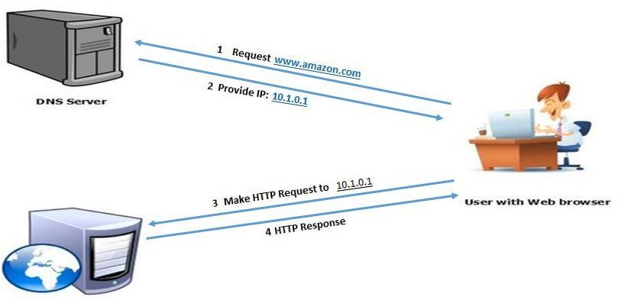

# Route 53

* DNS Service in AWS is called Route 53. We can register our domain name in Route 53, GoDaddy, freenon, etc.
* In Route 53 we have Five Routing Policies
* Simple Routing Policy
* Latency Routing Policy
* Failover Routing Policy
* Weighted Routing Policy
* Geolocation Routing Policy

# Route 53 - Simple Routing Policy

* This is the Default Routing Policy.
* This is most commonly used when we have a single region that performs a given function for our domain.
* AWS Route 53 responds to the DNS queries based on the values in the resource record set e.g. IP address in an A record



# Route 53 - Weighted Routing Policy

* Weighted Routing Policies let us split our traffic based on different weights assigned.
* For Example 80% of our traffic to go ap-south-1 & 20% of our traffic to go to ap-east-1

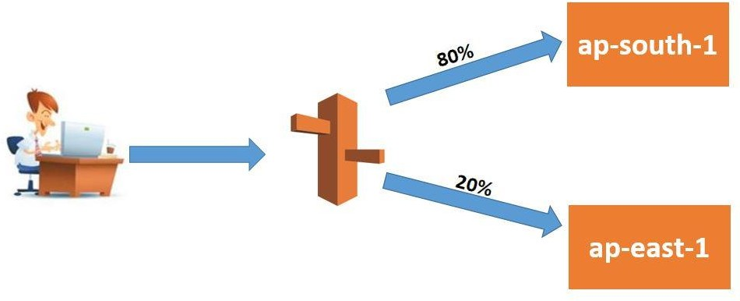

# Route 53 - Latency-based Routing Policy

* Latency-based routing allows us to route traffic based on the lowest network latency for our end users (i.e. which region will give them the fastest response time)

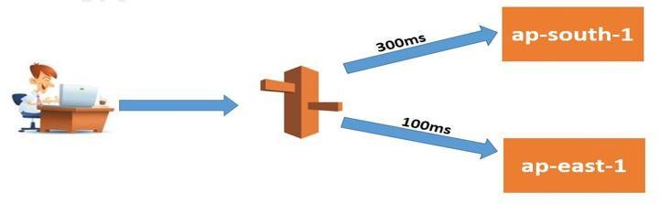

# Route 53 - Failover Routing Policy

* Failover routing policy allows active-passive failover configuration, in which one resource takes all traffic when it’s available and the other resource takes all

traffic when the first resource isn’t available.

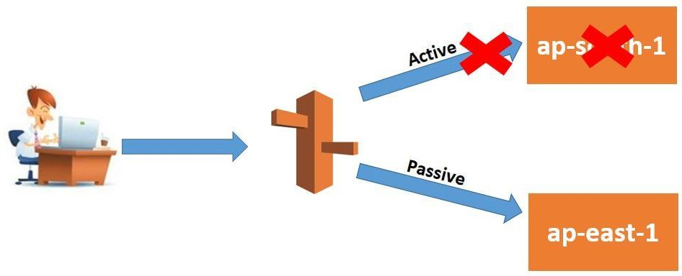Route 53 health-checking agents will monitor each location/endpoint of the application to determine the

availability

# Route 53 - Geolocation Routing Policy

* Geolocation routing lets you choose where your traffic will be sent based on the geographic location of your users.
* Geolocation routing policy allows geographic locations to be specified by continent, country, or state (only in the US)

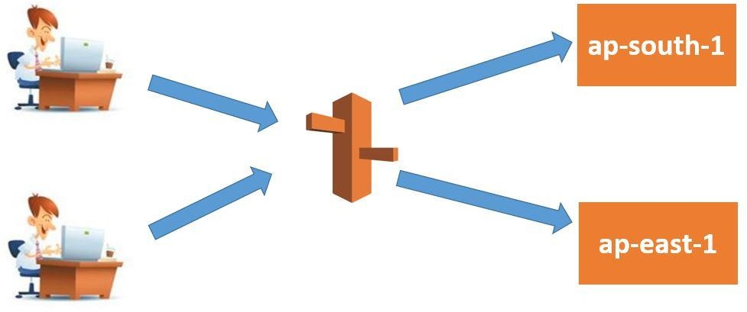

# Route 53

* Purchase a Domain from in our AWS Account
* Select Mumbai Region
* Create First EC2 Machine
* Add Bootstrap Script:

**#!/bin/bash**

**sudo su**

**yum update -y**

**yum install httpd -y**

**cd /var/www/html**

**echo "AmazonWebservices" > index.html**

**service httpd start**

**chkconfig httpd on**

* Create Security Group & Enable SSH & HTTP Port
* Create Second EC2 Machine
* Add Bootstrap Script:
* Create Security Group & Enable SSH & HTTP Port
* Create Target Group
* Select target type as instances
* Select both the machines in the target group
* Click on create target group
* Create Application Load Balancer
* Enter the Name of Load balancer
* Select all subnets
* Select Security group
* Select target group
* Click on Create load balancer
* Copy the DNS name & paste in browser
* Change Region to Sydney
* Create EC2 Machine
* Add Bootstrap Script:
* Create New Security group
* Enable SSH Port & HTTP Port
* Create Target Group
* Select target type as instances
* Select the machine in the target group
* Click on create target group

# Route 53

* Create Application Load Balancer
* Enter the Name of Load balancer
* Select all subnets
* Select the Security Group
* Select target group
* Click on Create a load balancer
* Copy the DNS name & paste in browser